AWS Integration
In your AWS S3 account we have created a folder called ‘ragcloud’ which you can see in below screen and whatever file you upload from the application will be saved into this AWS folder.
Run the project in old ways only and once you execute file upload option then you can see that file will be saved inside AWS ‘ragcloud’ folder.
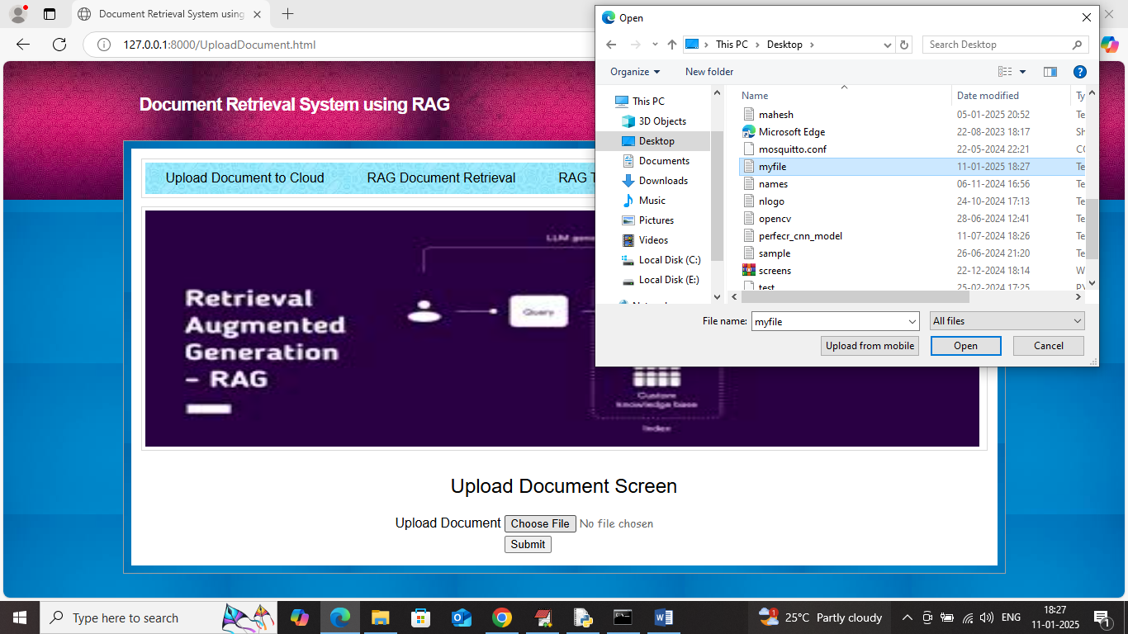
In above screen selecting and uploading ‘myfile.txt’ file and then click on ‘Open and submit’ button to upload that file AWS and get below page
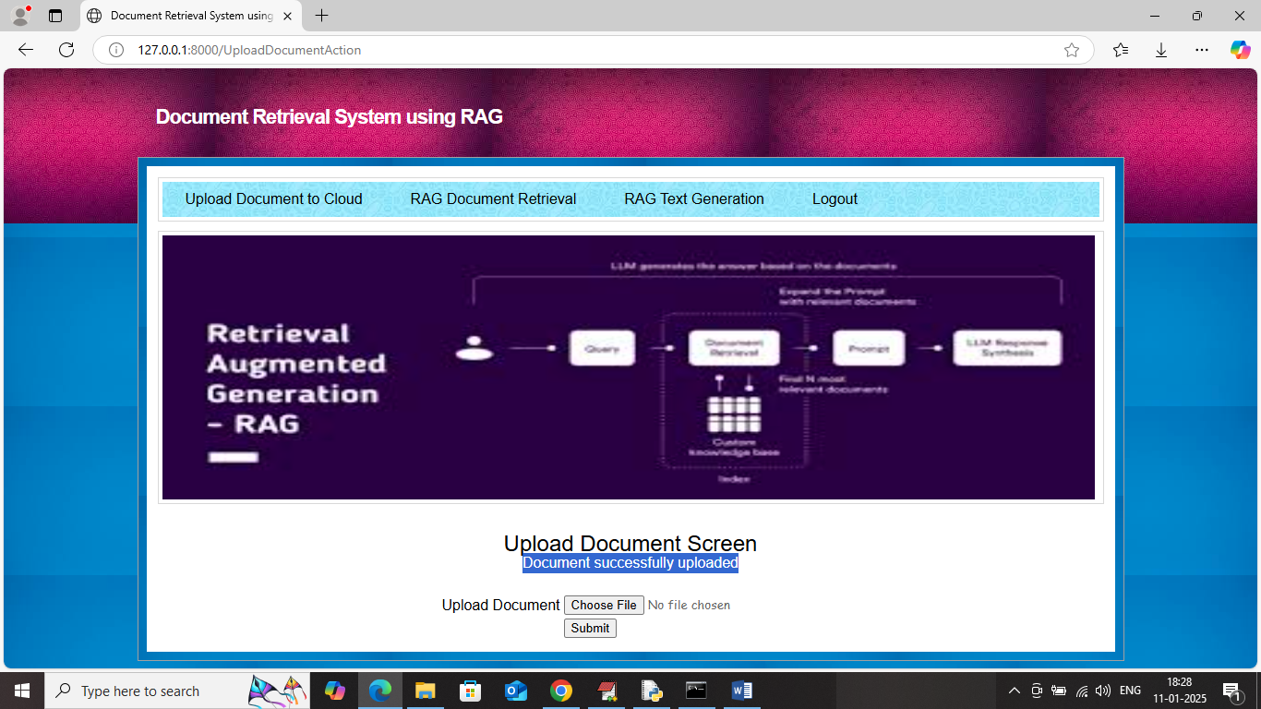
In above screen document successfully uploaded and now can check that file in AWS account in below screen
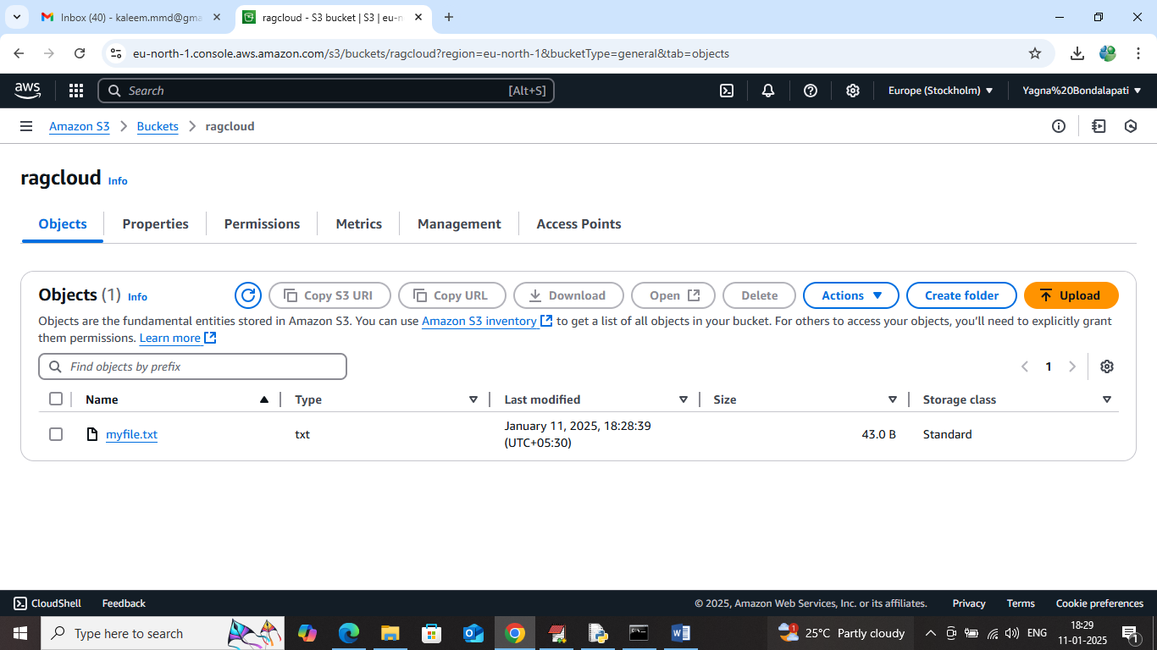
In above screen in ‘ragcloud’ bucket can see ‘myfile.txt’ file saved and similarly you can upload document from your application and will get saved in above AWS account.
Search and text generator modules you can run same as old module

Install below package by using this command
pip install boto3==1.33.13
pip install botocore==1.33.13

